**How to run the sensitivity analysis code and visualize the results**

1. Open **StatCanMicroSimTeam_SEIR sweep.r**
2. Set the work directory to the appropriate location on your own computer-



1. By default this code runs **Example 4- Random attempts multivariate**, which allows you to sweep across several parameters simultaneously.

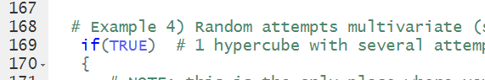

1. To modify example 4, change the name(s) and start values of the parameter(s) on the following line:



1. To change the number of simulations you want to run, change the following line; it is set at 400 by default, which takes about 1 hour to run.



1. Run the code. In the console window you will see the following message as the code iterates through the simulations:



1. After the iterations complete, the code will pause and produce a scatter plot. The user needs to choose one of the points on the scatter plot and hit the Finish button in the top right hand corner of the plot to complete.

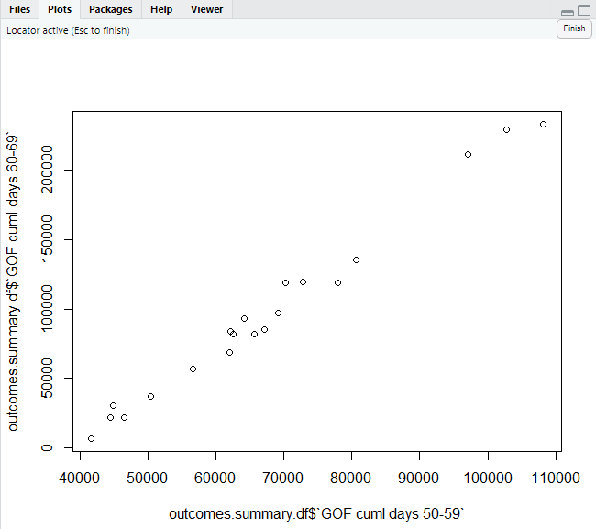

1. The code will produce a few important data frames, including **outcomes.summary.df**, which gives you a summary of the important outcome variables, including max incidence, max cases, attack rate etc. for each of the simulations (default 400). **df.sweep** is also an important data frame that gives you the value of each compartment at each time point for each simulations- this is a large file.
2. To visualize the scatter and tornado plots open the **app.r** code that comes in the same file. The app.r code will use the **outcomes.summary.df** to create the scatter and tornado plots.
3. Run the code by clicking Run App, in the upper right of your coding window.

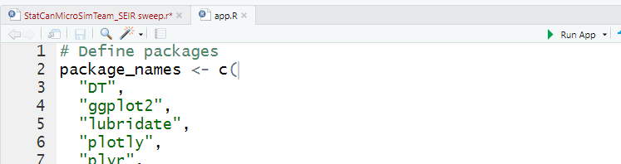

1. A window will appear that allows you to scatter plot different outcomes against different values of the parameters multipliers- either on the Y or X axes.

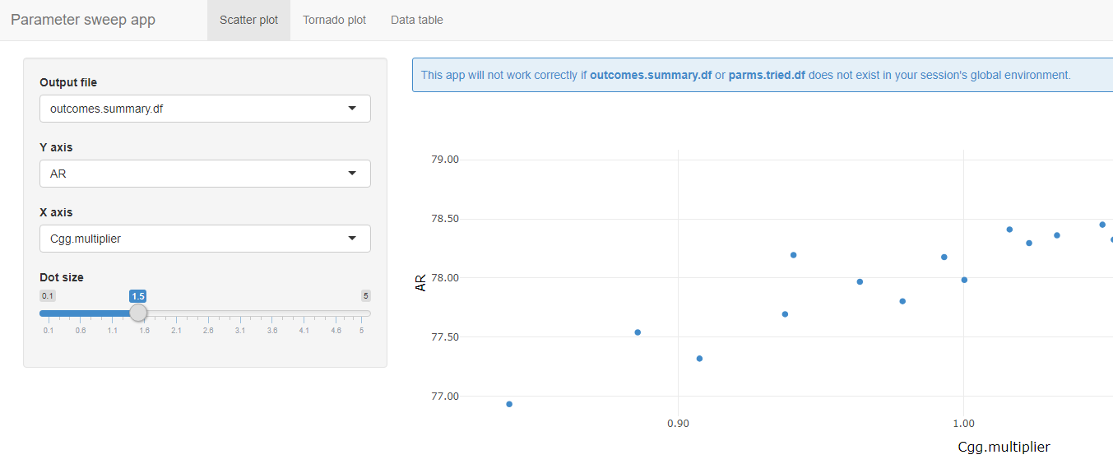

1. Click on the next tab to look at the tornado plots.

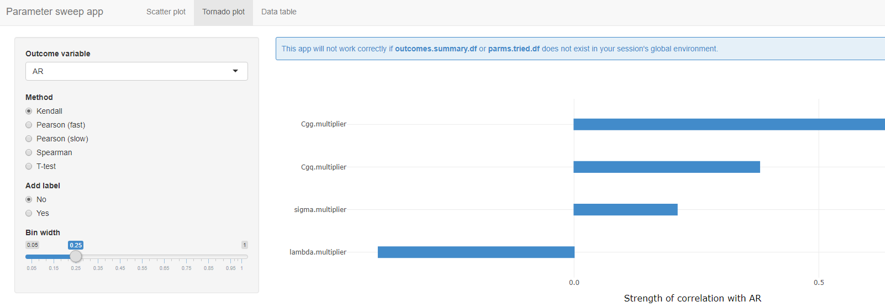

1. To download the plots as png, use the Plot tools by moving your mouse to the right hand side of the plot screen.

